VEL TECH HIGH TECH
Dr. RANGARAJAN Dr. SAKUNTHALA ENGINEERING COLLEGE
An Autonomous Institution



DROWSINESS DETECTION SYSTEM USING MACHINE LEARNING

A MINI PROJECT REPORT

Submitted by

SHARUN KUMAR C R (113019104086)
PAVAN KALYAN S (113019104063 )

COMPUTER SCIENCE AND ENGINEERING

VEL TECH HIGH TECH
Dr. RANGARAJAN Dr. SAKUNTHALA ENGINEERING COLLEGE
An Autonomous Institution

BONAFIDE CERTIFICATE

Certified that this mini project entitled “DROWSINESS DETECTION SYSTEM USING MACHINE LEARNING” is the bonafide work of

SHARUN KUMAR C R (113019104086)
PAVAN KALYAN S (113019104063)

who carried out the work under my supervision.

SIGNATURE SIGNATURE

Dr. S Durga Devi Mrs. Sheela Shanta Kumari
HEAD OF THE DEPARTMENT SUPERVISOR
Assistant Professor
Computer science and engineering Computer science and engineering

TABLE OF CONTENTS
CHAPTER NO. TITLE PAGE NO.

ABSTRACT 1

- INTRODUCTION 2
1.1 Purpose 2
1.2 Intended Audience 3
1.3 Product Scope 3
1.4 Problem Statement 3

- LITERATURE SURVEY 4
2.1 System Review 4
2.2 Technology Used 4
a.Python 4
b. Jupyter Lab 5
c. Image Processing 5
d. Machine learning 5

- REQUIREMENTS 6
3.1 Hardware requirement specification 6
3.2 Software requirement specification 6
- METHODOLOGY 7
- SYSTEM DESIGN 8
- SYSTEM FLOW 9
6.1 DataSet 9
6.1.1 Introduction 9
6.1.2 Annotation 10
6.2 Splitting the dataset 11
6.2.1 splitting into open and closed eye 11
6.2.2 splitting into train and test data set 12
6.3 Modelling 13
6.4 Model Accuracy 14
6.5 Model Implementation 14
6.5.1 Capture Video Frame 14
6.5.2 Detect Face in the Image and Create a
Region of Interest (ROI) 15
6.5.3 Detect the eyes from ROI and feed it to the classifier 15
6.5.4 Classifier will Categorize whether Eyes are Open
or Closed 16
6.5.5 Calculate Score to Check whether Person is Drowsy 16
- RESULT AND DISCUSSION 17
- CONCLUSION AND FUTURE WORKS 19
- REFERENCES 20

DROWSINESS DETECTION SYSTEM USING
MACHINE LEARNING

ABSTRACT

Drowsiness can be defined as a feeling of being lethargic and sleepy. A state of drowsiness when coupled with driving can be life threatening. Drowsiness can be caused due to several reasons like sleep deprivation, excess fatigue due to long road trips, excessive workload etc. Driving vehicles in such situations can lead to brief states of unconsciousness which can be very dangerous. Every year, a lot of people lose their lives due to road accidents. This includes both the drivers as well as the pedestrians. This also causes injuries and financial losses to a lot of individuals. In this paper, we try to leverage machine learning models with keras to find out the critical factors that can help us in detecting drowsiness amongst drivers based on their facial features. We have developed an end-to-end drowsiness detection system which takes videos of a person as input and predict whether driver is drowsy or not. We believe, our proposed system will be helpful for the society and help us resolve one of the major problems of drowsy driving.

Keywords: Driver drowsiness; eye detection; yawn detection; blink pattern; TensorFlow; Machine Learning; CNN; Keras; Deep Learning; HaarCascade File; Face Detection; Alert system ;

Chapter 1 Introduction

1.1 PURPOSE:

Drowsy driving is a major societal problem which needs to be addressed. Feeling drowsy while driving is not just sleeping, but it could also be brief spans in which we do not have full concentration on driving and our eyes are closed or distracted. This small amount of distraction could prove fatal in many situations. To address this problem, we propose a drowsiness detection system capable of capturing the drowsy states of a driver even for small time frames and thus could help in preventing major road accidents, injuries and losses. Our system takes input in the form of videos of drivers, extracts image frames from these videos and also extracts the facial landmarks for each of these frames. One we have the facial landmarks extracted from the frames, we then leverage classification models and deep learning concepts that predict the state of the driver as ‘Alert’ or ‘Drowsy’ and send the email alert to the owner .

1.2 INTENDED AUDIENCE:

The intended audience for this document are the development team, the project evaluation jury, and other tech-savvy enthusiasts who wish to further work on the project.

1.3 PRODUCT SCOPE:

There are many products out there that provide the measure of fatigue
level in the drivers which are implemented in many vehicles. The driver drowsiness detection system provides the similar functionality but with better results and additional benefits. Also, it alerts the user on reaching a certain saturation point of the drowsiness measure.

1.4 PROBLEM STATEMENT:

Fatigue is a safety problem that has not yet been deeply tackled by any country in the world mainly because of its nature. Fatigue, in general, is very difficult to measure or observe unlike alcohol and drugs, which have
clear key indicators and tests that are available easily. Probably, the best solutions to this problem are awareness about fatigue-related accidents and promoting drivers to admit fatigue when needed. The former is hard and much more expensive to achieve, and the latter is not possible without the former as driving for long hours is very lucrative

Chapter 2 LITERATURE SURVEY

2.1 SYSTEM REVIEW
This survey is done to comprehend the need and prerequisite is
general population, and to do as such, we went through different sites and applications and looked for the fundamental data. Based on these data, we made an audit that helped us get new thoughts and make different arrangements for our task. We reached the decision that there is a need of such application and felt that there is a decent extent of progress in this field too.

2.2 TECHNOLOGY USED

a. PYTHON - Python is an interpreted, high-level, general-purpose programming language. Python's design philosophy emphasizes code readability with its notable use of significant whitespace. Its language constructs and object-oriented approach aim to help programmers write
clear, logical code for small and large-scale projects. Python is dynamically typed AND supports multiple programming paradigms, including procedural, object-oriented, and functional programming.

b. JUPYTER Lab - Project Jupyter is a nonprofit organization created to develop open-source software, open-standards, and services for interactive computing across dozens of programming languages.

c. IMAGE PROCESSING - In computer science, digital image processing is the use of computer algorithms to perform image processing on digital images.

d. MACHINE LEARNING - Machine learning is the scientific study of algorithms and statistical models that computer systems use in order to perform a specific task effectively without using explicit instructions, relying on patterns and inference instead. It is seen as a
subset of artificial intelligence. Machine learning algorithms build a mathematical model based on sample data, known as "training data", in order to make predictions or decisions without being explicitly told.

Chapter 3 REQUIREMENTS

3.1 Software Requirements Specification
- Python:
Python 3.8
  - Python 3
- Libraries:
- Numpy
- Scipy
- Playsound
- Dlib
- Imutils
- Tensorflow
- Keras
- Opencv etc
  - Numpy
  - Scipy
  - Playsound
  - Dlib
  - Imutils
  - opencv, etc.
- Operating System :
- Windows or Ubuntu
• Windows or Ubuntu

3.2 Hardware Requirements Specification:

- Processor with 2 GHz frequency.
- In-built web-camera.
- A minimum of 2 GB of RAM
- Minimum 1024 X 768 monitor resolution.
- 20GB minimum storage

Chapter 4 METHODOLOGY

In this Python project, we will be using OpenCV for gathering the images from webcam and feed them into a Deep Learning model which will classify whether the person’s eyes are ‘Open’ or ‘Closed’.

The approach we will be using for this Python project is as follows :

- Step 1 – Take video as input from a camera.
- Step 2 – Detect the face in the image and create a Region of Interest (ROI).
- Step 3 – Detect the eyes from ROI and feed it to the classifier.
- Step 4 – Classifier will categorize whether eyes are open or closed.
- Step 5 – Calculate score to check whether the person is drowsy.
- Step 6 – If person is drowsy then play the alarm sound and send email to the owner .

Chapter 5 System Design

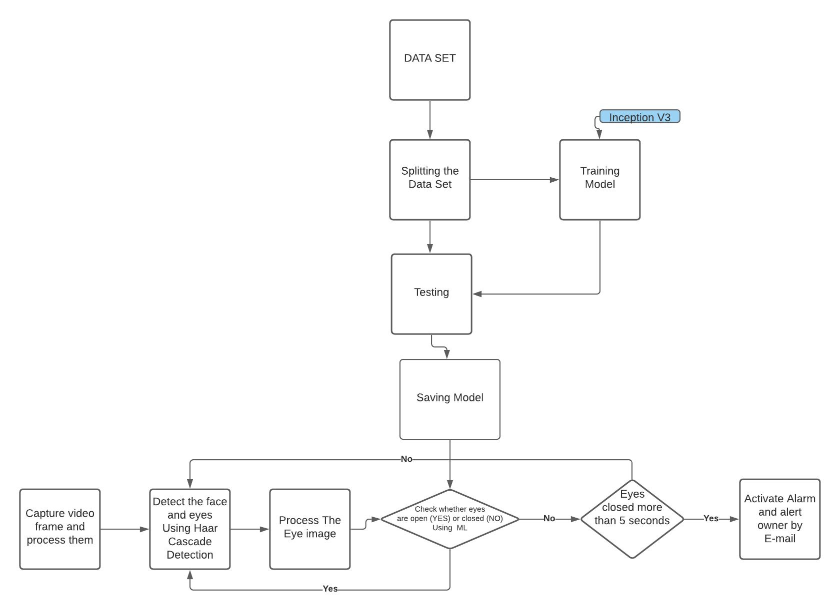

- Flow chart of our proposed project

Chapter 6 System Flow

6.1 DATASET

We used MRL EYE DATASET for training our model to predict whether driver is drowsy or not
6.1.1 Introduction :
MRL Eye Dataset is the large-scale dataset of human eye images. The detection of eyes and their parts, gaze estimation, and eye-blinking frequency are important tasks in computer vision. In last years, we have been solving these tasks in the area of driver's behaviour, which causes the acquiring of a lot of testing data that was acquired in real conditions. Therefore, we introduce the MRL Eye Dataset, the large-scale dataset of human eye images. This dataset contains infrared images in low and high resolution, all captured in various lightning conditions and by different devices. This dataset contains infrared images in low and high resolution, all captured in various lightning conditions and by different devices.
The annotation for approximately 15 000 pupil points (images)

6.1.2 Annotations :
In the dataset, we annotated the following properties (the properties are indicated in the following order):
- subject ID; in the dataset, we collected the data of 37 different persons (33 men and 4 women)
- image ID; the dataset consists of 84,898 images
- gender [0 - man, 1 - woman]; the dataset contains the information about gender for each image (man, woman)
- glasses [0 - no, 1 - yes]; the information if the eye image contains glasses is also provided for each image (with and without the glasses)
- eye state [0 - closed, 1 - open]; this property contains the information about two eye states (open, close)
- reflections [0 - none, 1 - small, 2 - big]; we annotated three reflection states based on the size of reflections (none, small, and big reflections)
- lighting conditions [0 - bad, 1 - good]; each image has two states (bad, good) based on the amount of light during capturing the videos
- sensor ID [01 - RealSense, 02 - IDS, 03 - Aptina];
at this moment, the dataset contains the images captured by three different sensors (Intel RealSense RS 300 sensor with 640 x 480 resolution, IDS Imaging sensor with 1280 x 1024 resolution, and Aptina sensor with 752 x 480 resolution)

6.2 SPLITING THE DATASET

6.2.1 SPLITTING INTO OPEN EYES AND CLOSED EYES

Above data set eye images then it is classifying it as open eye and closed eye it is classified based on the file name in the data set fifth label indicate the state of eye wheter open or closed .

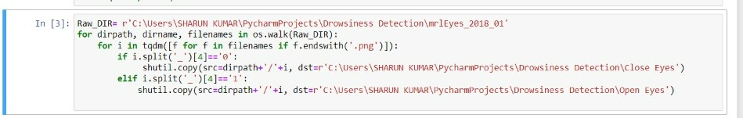

By executing above code our data set is splitted into closed eyes and open eyes so that it useful to detect whether driver is drowsy or not

6.2.2 SPLITTING INTO TRAIN AND TEST DATA SET

Splitted data set is classifying it as Test and Train data set using below code:

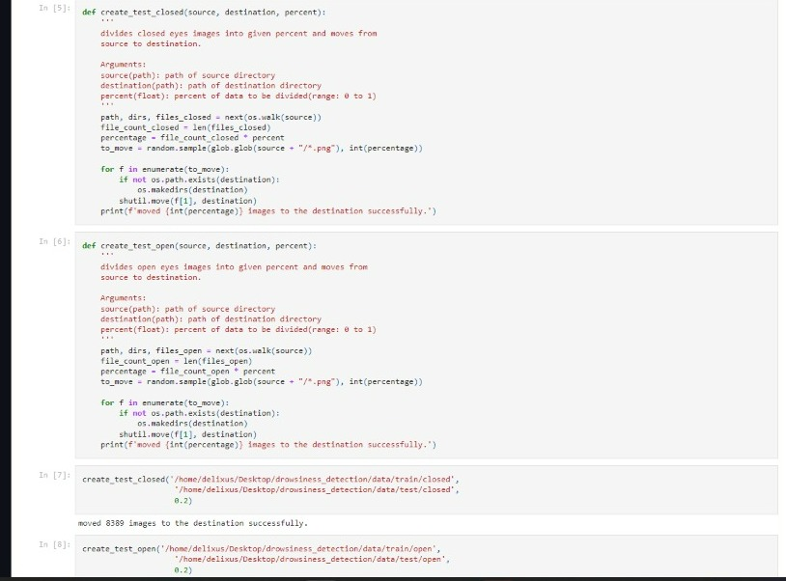

6.3 MODELLING
For model building, we have followed the below approches:– Random split. Here, we have performed a train-test shuffle. We have trained our models on eye data set using Inception V3 model. This approach would help us evaluate our models on unseen facial features as the facial features of the test participant would not be present in the training dataset. This will help us estimate the out-of-sample accuracy of our models.

Our model summary is given below :

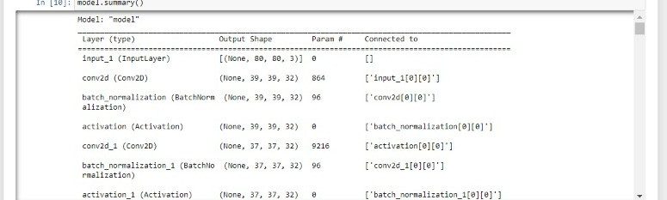

And then model is trained with 5 epochs using Adam Optimizer and Categorical cross entropy and then model is saved as “model.h5”

6.4 MODEL ACCURACY

After training the model with Inception V3 we get accuracy of our model as 94% and then the model is saved for using with live camera



6.5 MODEL IMPLEMENTATION

6.5.1 Capture Video Frame :

With a webcam, we will take images as input. So to access the webcam, we made an infinite loop that will capture each frame. We use the method provided by OpenCV, cv2.VideoCapture(0) to access the camera and set the capture object (cap). cap.read() will read each frame and we store the image in a frame variable.
6.5.2 Detect Face in the Image and Create a Region of Interest (ROI)

To detect the face in the image, we need to first convert the image into grayscale as the OpenCV algorithm for object detection takes gray images in the input. We don’t need color information to detect the objects.

We will be using haar cascade classifier to detect faces.

This line is used to set our classifier face = cv2.CascadeClassifier(‘ path to our haar cascade xml file’). Then we perform the detection using faces = face.detectMultiScale(gray). It returns an array of detections with x,y coordinates, and height, the width of the boundary box of the object. Now we can iterate over the faces and draw boundary boxes for each face.



6.5.3 Detect the eyes from ROI and feed it to the classifier :

The same procedure to detect faces is used to detect eyes. First, we set the cascade classifier for eyes as eye respectively then detect the eyes using eye = eye.detectMultiScale(gray). Now we need to extract only the eyes data from the full image. This can be achieved by extracting the boundary box of the eye and then we can pull out the eye image from the frame with this code.
_eye = frame[ y : y+h, x : x+w ]

eye only contains the image data of the eye. This will be fed into our Inception V3 classifier which will predict if eyes are open or closed.

6.5.4 Classifier will Categorize whether Eyes are Open or Closed
We are using INCEPTION V3 classifier for predicting the eye status. To feed our image into the model, we need to perform certain operations because the model needs the correct dimensions to start with. First, we convert the color image into grayscale using eye = cv2.cvtColor(eye, cv2.COLOR_BGR2GRAY). Then, we resize the image to 24*24 pixels as our model was trained on 24*24 pixel images cv2.resize(eye, (24,24)). We normalize our data for better convergence eye = r_eye/255 (All values will be between 0-1). Expand the dimensions to feed into our classifier. We loaded our model using model = load_model(‘MODEL.h5’) . Now we predict each eye with our model
lpred = model.predict_classes(eye). If the value of lpred[0] = 1, it states that eyes are open, if value of lpred[0] = 0 then, it states that eyes are closed

6.5.5 Calculate Score to Check whether Person is Drowsy
The score is basically a value we will use to determine how long the person has closed his eyes. So if both eyes are closed, we will keep on increasing score and when eyes are open, we decrease the score. We are drawing the result on the screen using cv2.putText() function which will display real time status of the person.

A threshold is defined for example if score becomes greater than 15 that means the person’s eyes are closed for a long period of time. This is when we beep the alarm using sound.play() and an email is sent to owner that driver is sleeping .

CHAPTER 7 :

RESULTS AND DISCUSSION

Let’s execute drive drowsiness detection system and see the working of our ml project. To start the project, you need to run the code which is already typed in jupyter note book .

- Sample output for when eyes are open and driver is alert :
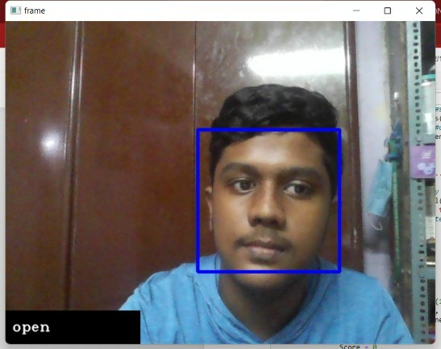

(ii) Sample output for eyes is closed for more than 15 threshold then driver is drowsy it will alert the driver with beep alarm and will send the alert to vehicles owner via email
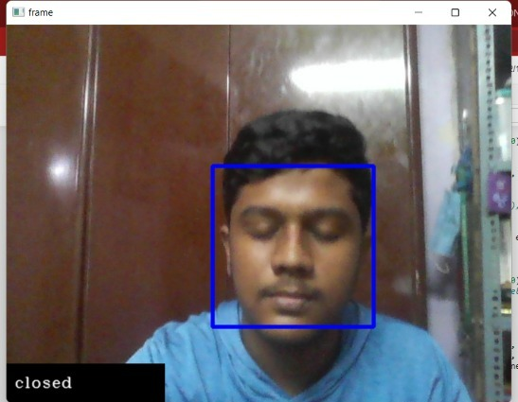

Sample output for driver is drowsy and email alert sent to owner



CHAPTER 8 :

CONCLUSION AND FUTURE SCOPE

The drowsiness detection and correction system developed here is capable of detecting drowsiness in a rapid manner. The system which can differentiate normal eye blink and drowsiness can prevent the driver from entering the state of sleepiness while driving. The system works well even in case of drivers wearing spectacles and under low light conditions also. As a complete abnormality detection system, this system can be further developed by adding different sensors and lane detection camera with appropriate hardware units and controller, which can deliver highly accurate detection techniques. The system can be commercially generalized and well employed in today’s vehicles with comparatively fewer expenses. As a whole, the system when equipped with the vehicles can reduce the traffic collisions occurring, related dangers and expenses in our country

REFERENCES

[1] Makowiec-Dąbrowska T. et al.: Zmęczenie pracą u kierowców autobusów
miejskich (Workfatigue in Urban bus driver”, article of the Institute of
Occupational Medicine im. Professor J. Nofer, Łódź 2015 (in Polish).
[2] Statistics related to fatique due to drivers {Available – 2017.06.01:
http://www.orlenbezpiecznedrogi.pl/downloads/material-backgroundowy.doc}
(in Polish).
[3] The fatique detection system implemented in cars Ford {Available –
2017.06.01:http://www.technowinki.onet.pl/motoryzacja/system-monitorowania-
koncentracji-kierowcy-w-samochodzie-ford-focus/6f4kdg} (in Polish).
[4] The fatique detection system used in the car Skoda Octavia
{Available – 2017.06.01: http://www.mojafirma.infor.pl/moto/eksploatacja-
auta/bezpieczenstwo/315625,2,Skoda-Octavia-systemy-bezpieczenstwa.html}
(in Polish).
[5] Skoda brand fatique detection system {Available – 2017.06.01:
http://www.sklep.skoda.pl/upload/files/Fabia_3_akcesoria_2015-01.pdf} (in
Polish).
[6] Bosch Drowsiness System {Available – 2017.06.01: http://www.bosch-
prasa.pl/informacja.php?idinformacji=1356}.
[7] Pawelec J., Krawczyk Z.: „Bezpieczeństwo w ruchu drogowym. Możliwości i
przykłady zastosowań nowych technologii”, Transcomp – XIV International
Conference Computer Systems Aided Science, Industry and Transport.
[8] View at driver fatigue information (Ford Driver Assistant)
{Available – 2017.06.01: https://cbsdetroit.files.wordpress.com/2011/10/ford-
warning.jpg?w=601}.
[9] Information about the vision system for fatique detection {Available –
2017.06.01: http://www.neuroblog.pl/video/kamera-monitorujace-emocje-
kierownica/} (in Polish).
47
[10] Information about the video fatique detection system {Available – 2017.06.01:
https://actu.epfl.ch/news/tracking-facial-features-to-make-driving-safer-and/} (in
Polish).

[11] Information about the driver fatique vision system developed by the PSA in
cooperation with the Technical University of Lausanne
{Available – 2017.06.01: https://www.autocar.co.uk/car-news/industry/psa-
peugeot-citroen-shows-new-cabin-technology} (in Polish).
[12] Driver Drowsiness Detection System using EEG (picture from Gang Li and
Wan-Young Chung, “A Context-Aware EEG Headset System for Early
Detection of Driver Drowsiness”, Department of Electronic Engineering,
Pukyong National University, Busan, Korea, MDPI article)
{Available – 2017.06.01: http://www.mdpi.com/1424-8220/15/8/20873/htm}.
[13] Naruniec J.: Metody częstotliwościowo-przestrzenne w detekcji i śledzeniu
charakterystycznych punktów twarzy, PhD Thesis, PW EiTI (in Polish).
[14] Nazimek M.: Porównanie skuteczności algorytmów detekcji ruchu dla systemów
wizyjnych ruchu ulicznego w wykrywaniu pojazdów, master thesis, PW EiTI.
[15] Ambroziak L., Cieśluk J., Gosiewski Z.: Metoda rozpoznawania przeszkód przez
bezzałogowy statek powietrzny z wykorzystaniem jednej kamery, Transactions of
the Institute of Aviation, Institute of Aviation in cooperation with the Bialystok
University of Technology (in Polish).
[16] Algorytm Horn-Schunk {Available – 2017.06.01:
http://www.ee.pw.edu.pl/~jarek/Estymacja/hornSchunck.htm}.
[17] Horn–Schunck method {Available – 2017.06.01:
https://en.wikipedia.org/wiki/Horn%E2%80%93Schunck_method}.
[18] Example of using optical flow (picture from Carmelo Militello, Leonardo Rundo,
Maria Carla Gilardi, “Applications of imaging processing to MRgFUS treatment
for fibroids: a review”, Istituto di Bioimmagini e Fisiologia Molecolare-Consiglio
Nazionale delle Ricerche (IBFM CNR-LATO), Cefalù (PA), Italy, article from
Translational Cancer Research) {Available – 2017.06.01:
http://tcr.amegroups.com/article/view/3200/html}.

